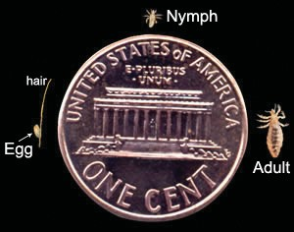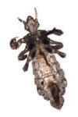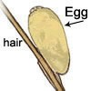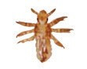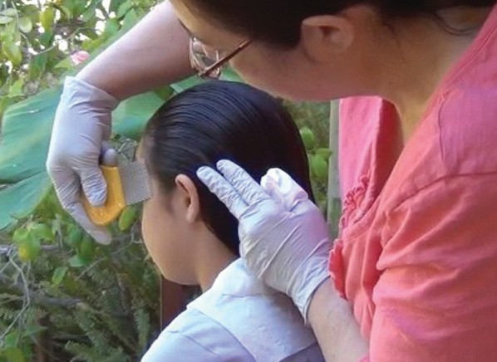
What are head lice?
Head lice are tiny, wingless insects that only live on humans. They live in the hair close to the scalp and feed on blood. Lice glue their eggs, or “nits” to hair.
How do you get head lice?
There are millions of cases of lice each year in the United States, mostly among children ages 3 to 11. Head lice do not jump, fly, or hop. They are spread through direct head-to- head contact, and less often by sharing combs, hats, clothing, headphones, or other personal items. Children are much more likely to get lice from family members and playmates than from classmates at school.

Life Cycle and Development
Adult female lays eggs (nits) on hair
In about 7 days, eggs hatch
into nymphs

Nymphs mature into egg-laying adults about 7 days after hatching
What do I look for?
Look through the hair, especially at the back of the head and behind the ears. Lice are difficult to see because they hide and blend in with the hair, so look for eggs which are yellowish-white and close to the scalp. Don’t confuse dandruff or dirt with eggs. Eggs are glued on the hair and you must pinch the egg and gently slide it down the hair to remove it.
Can you prevent head lice? Head Lice cannot be totally prevented but by routinely checking your child’s head you can catch an infestation early, making treatment easier.
Teach your child to:
- Never share brushes, combs, hats, coats, or other personal items.
- Avoid piling their coats and hats on top
of other children’s.
- Take their own pillow to a sleepover party, and wash the pillowcase afterward.

Inspect your child’s hair and scalp frequently. You can use a metal lice comb to screen for lice once a week. Move the hair in sections, and carefully look for eggs. A thorough lice check takes at least 10 minutes.

Photos Courtesy of: Centers for Disease Control and Prevention (CDC) and Identify US

What are Treatment Options?
Head lice should be treated with a shampoo or medication specifically labeled for head lice. There are over-the- counter (OTC) and prescription products available.
- Follow label directions carefully.
- Do not leave the product on for longer
than recommended.
- Do not split a single box of over-the- counter lice shampoo between people.
- Make sure to retreat in 7 to 10 days, if directed. Remove eggs during this period.
- Even after treatment, spend time each day removing eggs until all eggs are removed. Use a metal lice/nit comb. The best way to remove eggs is to part hair into small sections. As each section is combed, fasten the hair with a hair band or clip to keep track of what has been combed. It is easier to comb wet hair. When eggs cannot be combed out, manually remove them by pinching the egg and sliding it off the hair.
Do I Need to Treat My House? Lice only live for a day or two off of a human.
- Bed linens, recently worn clothes, hats
and coats should be washed in hot water and dried in the dryer on high heat for at least 30 minutes. Dry cleaning also kills head lice.
- Vacuum floors, carpets, furniture and
car seats and dispose of vacuum bag.
- Combs, brushes, and hair accessories should be discarded or soaked in hot water with some of the lice shampoo or in rubbing alcohol for one hour.
- Seal items in a plastic bag for two weeks
if they have been in recent contact with the infected person and cannot be washed, such as stuffed animals and pillows.
- Do not use bug sprays; they can be toxic
if inhaled or absorbed through the skin.

I Still Have Questions . . .
Should I cut my child’s hair?
- No, it is not necessary to cut the hair. It is important to use a lice or nit comb to remove eggs.
Do I need to throw away personal items or toys?
- No, follow the instructions for treating the
home. Even those favorite stuffed animals will be fine after two weeks in a plastic bag. Do I need to treat my pets?
- Head lice cannot live on pets.
What about alternatives to OTC and prescription medications like essential oils, mayonnaise, etc.?
- We know alternative therapies can be
found on internet websites. However, their success in treating both live lice and eggs is unclear. Many involve the use of oils which may suffocate adult lice but not kill the eggs. When these oil based treatments are used it is important to comb out all eggs (nits).
- NEVER USE ANY FLAMMABLE PROD-
UCTS SUCH AS KEROSENE OR ALCOHOL.
FIND MORE INFORMATION ONLINE
American Academy of Pediatrics, US Center for Disease Control (CDC), Kids Health

Contact your School Nurse for Confidential Assistance

GREENVILLE INDEPENDENT SCHOOL DISTRICT

